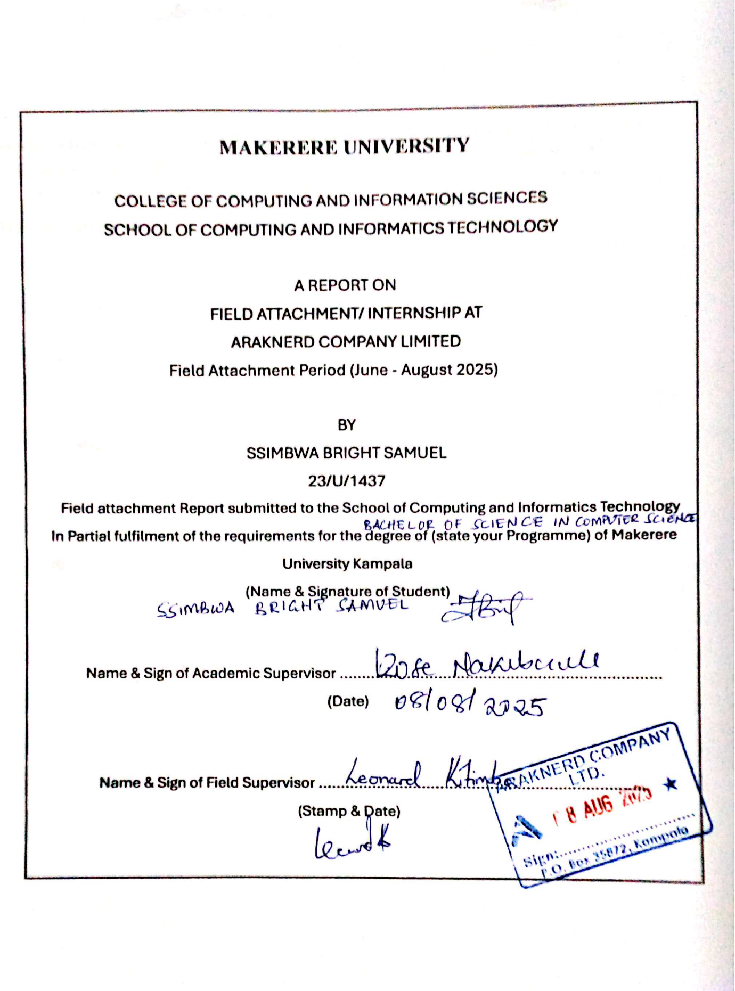

**iii. ACKNOWLEDGEMENTS**

I would like to express my sincere gratitude to all those who contributed to the successful completion of my field attachment at Araknerd Company Limited.

First and foremost, I thank the Almighty God for granting me the strength, wisdom, and good health throughout the attachment period.

I am deeply grateful to my field supervisor at Araknerd Company Limited for the guidance, mentorship, and technical support provided throughout the attachment. The learning environment created was conducive to professional growth and skill development.

I extend my appreciation to all the technical staff at Araknerd Company Limited who shared their expertise and made my learning experience enriching. Special thanks to the development team who introduced me to modern technologies and real-world software development practices.

I acknowledge the management of Elite High School and Standard High School for allowing me to participate in their technical projects and gain practical field experience.

My gratitude goes to my academic supervisor from Makerere University for the continuous guidance and support throughout the attachment process.

Finally, I thank my family and friends for their moral support and encouragement during this period.

**iv. ABSTRACT**

This document provides a detailed review of my three-month internship at Araknerd Company Limited which operates as a modern software development company offering advanced technological solutions. The attachment period began in June and continued through August 2025 as I gained exposure to software development alongside embedded systems engineering.

Throughout my attachment I performed various technical tasks that included building React-based Node.js TypeScript web applications and programming Arduino microcontrollers for embedded systems while working on actual client projects. The attachment yielded significant results through the development of a stock management system and multiple company website creations as well as smart bin prototypes with IoT sensors and educational institution technical support.

The practical experience offered crucial knowledge about contemporary development methods together with project control and client dealings while uniting Makerere University theoretical education with real-world applications. The experience presented three major difficulties in backend-frontend integration and complex system debugging and hardware-software interface development which led to important educational benefits.

The work experience demonstrated how university classes match industry standards yet showed necessary improvements for academic programs. The following recommendations propose to boost practical project learning while integrating industry-standard tools into education and expanding academic-technology firm partnerships.

The report presents my work duties along with the knowledge gained and the issues I encountered. Field attachments play an essential role in connecting academic education to professional practice for technology professionals in the fast-changing technology industry.

**v. TABLE OF CONTENTS**

**DECLARATION**..................................................................................................................... ii

**ACKNOWLEDGEMENTS**...................................................................................................iii

**ABSTRACT** ........................................................................................................................... iv

**TABLE OF CONTENTS** ........................................................................................................v

**LIST OF FIGURES** ..............................................................................................................vii

**LIST OF TABLES** ................................................................................................................viii

**LIST OF ACRONYMS/ABBREVIATIONS.**.......................................................................ix

**CHAPTER ONE: INTRODUCTION**...................................................................................1

Introduction ............................................................................................................................1.1

Background of the Field Attachment ......................................................................................1.2

Objectives of the Field Attachment ........................................................................................1.3

Background of the Organization of Field Attachment ...........................................................1.4

Organizational Culture ...........................................................................................................1.5

The Structure of the Organization .........................................................................................1.6

The Main Activities of the Organization and Ongoing IT Projects .......................................1.7

**CHAPTER TWO: STUDENT'S EXPERIENCES** ..............................................................2

Title or Position Occupied in the Organization ..................................................................... 2.1

Duties and Responsibilities ....................................................................................................2.2

Supervision Levels and Relationship with Supervisor .........................................................2.3

Work Team and its Composition ...........................................................................................2.4

Working Relationship Among Team Members/Other Staff ..................................................2.5

**CHAPTER THREE: EVALUATION ON FIELD ATTACHMENT**...................................3

Level of Accomplishment of Duties and Responsibilities Assigned ......................................3.1

New Knowledge and Skills Gained in Each of the Duties and Responsibilities .................. 3.2

Most Interesting Experiences .................................................................................................3.3

Relatedness of University's Taught Programs to the Field of Work .......................................3.4

Challenges Faced and How Managed ....................................................................................3.5

Benefits Derived from Field Attachment ...............................................................................3.6

Adequacy in University's Preparing the Student for Field Attachment .................................3.7

Preparedness of the Agency to Receive and Manage Students for Field Attachment ……...3.8

Career Motivation ..................................................................................................................3.9

**CHAPTER FOUR: CONCLUSIONS AND RECOMMENDATIONS**...............................4

Conclusions ............................................................................................................................4.1

Recommendations ..................................................................................................................4.2

**REFERENCES**.........................................................................................................................5 **APPENDICES**.........................................................................................................................35

**Appendix A:** My Weekly Progress...............................................................................................35

**Appendix B:** Projects I Worked On ........................................................................................35

**Appendix C:** Photos and Screenshots.....................................................................................36

**Appendix D:** Code Samples....................................................................................................37

**Appendix E:** What I'd Tell Other Students..............................................................................39

**vi. LIST OF FIGURES**

Figure 1.1: Araknerd Company Limited Organizational Structure........................................... 9

Figure 1.3: BuzzTime booth……….........................................................................................15

Figure 1.4: Poolpay device………………………………………………………………...…15

Figure 3.1: Smart Bin Prototype Design Architecture.............................................................24

Figure 3.2: A company website page built with React and tailwind CSS................................25

Figure 3.3: A phpMyAdmin interface loaded with a database…….........................................26

Figure 3.4: A web app interface built with React and Node.js…….........................................26

Figure 3.5: Home Admin page of a Real-world system…….........................................……..26

**vii. LIST OF TABLES**

Table 1.1: Araknerd Company Services Portfolio.....................................................................9

Table 3.1: Skills Acquired During Field Attachment ..............................................................19

**viii. LIST OF ACRONYMS/ABBREVIATIONS**

CSS - Cascading Style Sheets

HTML - Hypertext Markup Language

IDE - Integrated Development Environment

IoT - Internet of Things

IR - Infrared

LCD - Liquid Crystal Display

LED - Light Emitting Diode

NCDC - National Curriculum Development Centre

Node.js - JavaScript Runtime Environment

OOP - Object-Oriented Programming

PCB - Printed Circuit Board

URL - Uniform Resource Locator

USSD - Unstructured Supplementary Service Data

PHP - Hypertext Preprocessor

UI - User Interface

UX - User Experience

SDK - Software Development Kit

WAMP - Windows, Apache, MySQL, and PHP

**1 CHAPTER ONE: INTRODUCTION**

**1.1 Introduction**

The report documents my complete field attachment experience at Araknerd Company Limited which lasted six months from June to August 2025. The field attachment served as a requirement for my Bachelor of Science in Computer Science degree program at Makerere University's School of Computing and Informatics Technology.

The report presents thorough information about modern software development company operations while detailing my individual experiences with learning results and practical applications of university knowledge. The attachment period exposed me to multiple technological areas such as web development and embedded systems and mobile application development together with client project implementation.

The documentation fulfills academic requirements for field attachment reporting and uses reflective analysis to provide recommendations about university curriculum and industry attachment programs. The report provides a structured overview which explains Araknerd Company Limited's business operations and my organizational responsibilities together with the key professional lessons I acquired.

My attachment experience created an important connection between theoretical education and practical industry work which introduced me to actual software development problems and client interaction methods as well as teamwork approaches in contemporary technology development. This report presents these experiences in detail to provide practical information which will benefit future students together with stakeholders.

**1.2 Background of the Field Attachment**

The Computer Science program at Makerere University requires students to complete field attachment for hands-on experience in real-world technology settings. The program connects classroom learning to professional industry experience by training students for success in today's rapidly changing technology industry.

The main goal of field attachment allows students to enter professional workplaces for knowledge application and skill development and industry practice learning. The practical experience allows students to comprehend software development complexities and project management as well as client relations and teamwork within contemporary technology environments.

The motivation for joining this field attachment stemmed from my need to acquire hands-on software development experience as well as to see programming concepts in practice and study embedded systems alongside IoT development technologies. The attachment allowed me to access industry-standard tools for project work alongside real client assignments that led me through the complete software development process from initial concept to final deployment.

This attachment took place at the perfect time since it followed my completion of programming basics and database systems and software engineering courses which enabled me to use fresh knowledge while spotting knowledge gaps. The professional experience was essential for guiding my career direction and learning how different technology professions work in real-life scenarios.

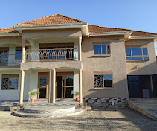

**Figure 1.1:** The structure of Araknerd Company Limited.

**Table 1.1: Araknerd Company Services Portfolio**

| **Service Category** | **Specific Services** | **Technologies Used** | **Target Market** |
| --- | --- | --- | --- |
| **Software Development** | Custom Software Solutions, Web Applications, Enterprise Systems | React, Node.js, PHP, JavaScript, TypeScript | Businesses, Government, NGOs |
| **Embedded Systems/Electronics** | IoT Solutions, Microcontroller Programming, PCB Design | Arduino, C++, Various Sensors, Circuit Design | Industrial, Consumer Electronics |
| **Product Prototyping** | 3D Printing, Proof-of-Concept Development, Design Services | CAD Software, 3D Printers, Rapid Prototyping | Startups, Manufacturers |
| **Developer Training** | Programming Courses, Technical Workshops, Capacity Building | Various Programming Languages, Hands-on Labs | Educational Institutions, Professionals |
| **Mobile Applications** | Native Apps, Cross-platform Solutions, Mobile-first Design | iOS/Android SDKs, React Native, Flutter | Consumer Market, Businesses |
| **Flagship Products** | BuzzTime (School Communication), PoolPay (Digital Pool Tables) | Mobile Apps, Hardware Integration, Cloud Services | Educational Sector, Entertainment Industry |

**1.3 Objectives of the Field Attachment**

The field attachment at Araknerd Company Limited was guided by several specific objectives designed to maximize learning outcomes and professional development:

**Primary Objectives:**

* To apply theoretical concepts learned in university courses including Object-Oriented Programming, Database Systems, Software Engineering, and Embedded Systems in real-world scenarios.
* To acquire hands-on experience with modern development tools, frameworks, and programming languages currently used in the technology industry.
* To understand the dynamics of working in a professional software development environment, including team collaboration, project management, and client interaction.
* To gain insights into current industry trends, best practices, and emerging technologies in software development and embedded systems.

**Secondary Objectives:**

* To explore various career paths within the technology sector and identify personal areas of interest and aptitude.
* To develop critical thinking and problem-solving abilities through exposure to real-world technical challenges.
* To enhance professional communication skills through interaction with team members, supervisors, and clients.
* To observe and participate in project planning, execution, and delivery processes.
* To understand the importance of code quality, testing procedures, and documentation in professional software development.
* To develop habits of continuous learning and adaptation necessary for success in the rapidly evolving technology landscape.

These objectives provided a framework for evaluating the success of the attachment experience and guided the selection of tasks and projects undertaken during the internship period.

**1.4 Background of Araknerd Company Limited**

Araknerd Company Limited is a premier software development firm established in 2017 and based in Kampala, Uganda. With over seven years of operational experience, the company visions to be the leading technological innovation in East Africa, serving diverse clients including educational institutions, private businesses, government agencies, and international organizations.

**Vision**

"To be the leading technology solutions provider in East Africa, recognized for innovation, quality, and transformative impact on businesses and communities."

**Mission**

"Araknerd is dedicated to crafting cutting-edge software solutions that cater to the unique needs of our clients, empowering them with technology that drives growth, efficiency, and success in the digital marketplace."

**Core Services include:**

* **Software Development:** Building custom software, web apps, and business systems using tools like React, Node.js, PHP, and databases.
* **Embedded Systems:** Creating smart devices, IoT solutions, microcontroller programs, and PCB designs for industries and everyday use.
* **Mobile Apps:** Making user-friendly apps for iOS and Android, both native and cross-platform.
* **Training and Consultancy:** Offering training for developers and tech advice to help organizations grow their skills.
* **Prototyping:** Using 3D printing and PCB design to turn ideas into real products quickly.

**Others:**

* Developer Training
* Mechatronics

**Key Performance Indicators**

The company maintains excellence through measurable outcomes including client retention rates above 90%, consistent project delivery within agreed timelines, and continuous revenue growth year-over-year.

**1.5 Organizational Culture**

Araknerd fosters a dynamic culture rooted in Innovation, Excellence, Integrity, Collaboration, and Customer-Centricity, creating an environment where creativity and technical expertise thrive.

**Cultural Pillars**

* **Innovation-Driven Culture:** Regular hackathons and innovation sessions encourage exploration of emerging technologies, reflected in projects like BuzzTime and PoolPay.
* **Collaborative Work Environment:** Cross-functional teams combine expertise in software, hardware, and user experience design, ensuring comprehensive solutions.
* **Continuous Learning:** Mentorship, training programs, and access to technical resources support professional development.
* **Quality Excellence:** Rigorous code reviews, testing, and adherence to industry standards ensure high-quality deliverables.
* **Client-Centric Approach:** Solutions are tailored to client needs, with regular feedback to enhance satisfaction.
* **Work-Life Balance:** Flexible arrangements and team-building activities maintain high employee morale.
* **Ethical Standards:** Transparent pricing, honest communication, and respect for intellectual property uphold integrity.

**1.6 The structure of the Organization**

Araknerd operates a lean structure with:

* Executive Management: CEO and CTO overseeing strategy and innovation.
* Development Teams: Software, embedded systems, mobile, and QA teams.
* Support Functions: Project management, business development, and administration.

Cross-functional teams ensure efficient collaboration on complex projects.

**1.7 The main Activities and Ongoing IT Projects**

Araknerd tackles a wide range of tech projects, using modern approaches like Agile and DevOps to get things done efficiently.

**Araknerd’s activities include:**

* Creating web and mobile applications using React, Node.js, and PHP.
* Implementing educational technology solutions, such as biometric systems and e-voting platforms.
* Developing apps for iOS and Android, used in schools, healthcare, and businesses.
* Designing IoT solutions and embedded systems.
* Prototyping through use of 3D printing and PCB design to test ideas and create working models.
* Helping organizations and developers build their tech skills through training.

**Flagship Products.**

* **BuzzTime:** Streamline the school experience with BuzzTime, a cutting-edge platform designed to enhance student communication. For secure voice and video calls. We provide safe, controlled and efficient solutions for educational institutions.
  + Voice notes & Video Calls: Children can make voice or video calls to their parents directly from the school phone booth.
  + Parental Control: Parents can easily manage who their child can contact, ensuring safe communication.
  + Call History: Keep track of your child's call history to monitor who they've been in contact with.
  + Message Sharing: Parents and children can share voice and text messages through the app, making it easy to stay connected.
  + Peace of Mind: BuzzTime helps bridge the gap between school and home, providing peace of mind for both parents and children.
  + Available on the App Store and Google Play.
* **PoolPay (Digital Pooltables):** Pool Pay is the ultimate app for billiards enthusiasts and pool table owners alike. Say goodbye to traditional coin slots and embrace a modern, convenient way to enjoy your favorite game. With Pool Pay, users can effortlessly release billiards from tables using their smartphones, eliminating the need for physical coins. For pool table owners, PoolPay offers powerful features to enhance business management.
  + How to use the USSD option: Simply dial *217*215, select option 3 (PoolPay) and follow the prompts. You can load coins, check your balance and play games.
  + Table info: Enter table reference. View table status.
  + New Vouchers: Purchase new vouchers on various tables.
  + Recent vouchers: View recent ones on various tables.
  + Play Now: Enter table code. Enter mobile money PIN to initiate a game.
  + Buy Coins: To buy coins, enter coin amount, confirm with mobile money PIN.
  + My account: View available coin balance.
  + My card: View card balance.
  + New card: Please purchase card from your nearest poolpay agent.
  + Available on the App Store and Google Play.

**Other Projects**

* Systems to manage student information for schools.
* Biometric systems to track attendance.
* E-voting platforms for student elections.
* Digital platforms for learning and education.
* Coding programs aligned with Uganda’s NCDC curriculum.
* Automated building control systems.
* Energy-saving platforms.
* Custom ERP systems for manufacturers.

**Client Interaction**

We build long-term relationships by offering ongoing support, regular updates, tech advice, and training to make sure our solutions keep delivering value.

**Figure 1.2:** BuzzTime booth installed at Elite High School.

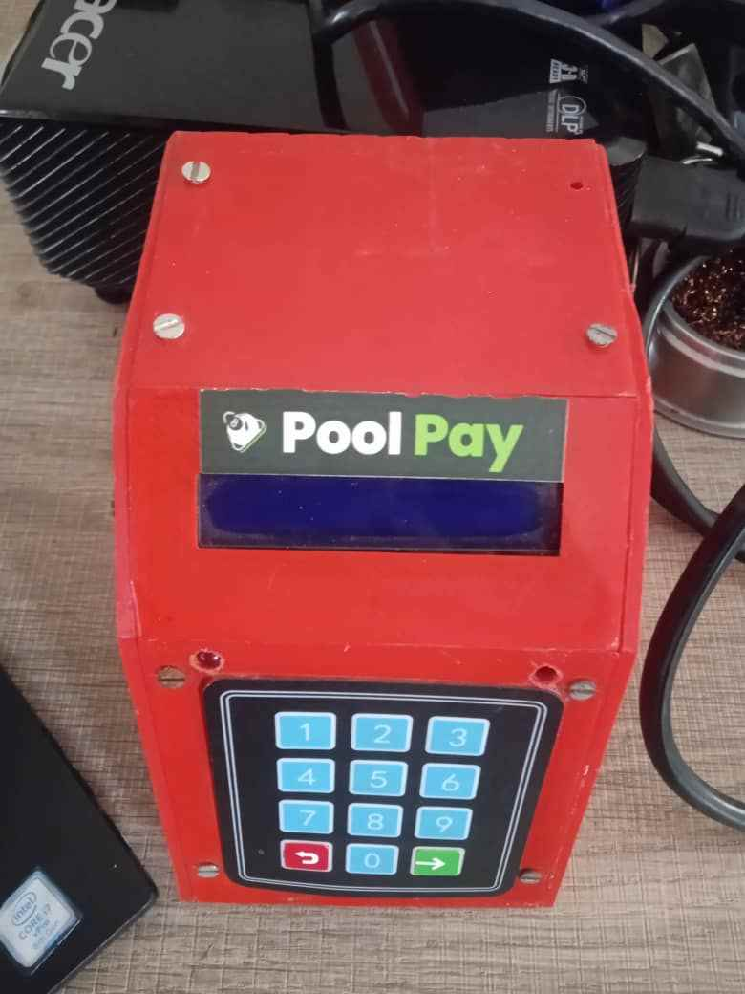

**Figure 1.4:** A picture of the pool pay device designed by the company.

**2 Chapter Two: Student Experiences**

**2.1 Title or Position Occupied in the Organization**

During my internship at Araknerd Company Limited, I worked as a Trainee Developer, splitting my time between software development and embedded systems engineering. This role allowed me to dive into both coding and hardware projects, giving me a hands-on taste of real-world tech development.

**2.2 Duties and Responsibilities**

My time at Araknerd was packed with diverse tasks that challenged me to apply my skills and learn new ones. Here’s what I worked on:

**Software Development:**

* Built a stock management app and a website using React, TypeScript, JavaScript, Tailwind CSS, and Node.js, focusing on clean code and user-friendly design.
* Explored PHP for front-end development and got a glimpse of Araknerd’s existing React-PHP system, which took years to build and showed me the scale of real-world projects. With guidance from the team, I successfully connected this system’s database to a local WAMP server to facilitate local testing and development, a critical step to ensure compatibility and functionality outside the usual terminal-based environment, thereby enhancing my understanding of server-side operations and system deployment.
* Learned to use MongoDB database, analyze and manage data for systems

**Embedded Systems:**

* Worked with an Arduino and components like IR remote sensors, infrared sensors, ultrasonic sensors, potentiometers, LEDs, servos, and a 16x2 LCD.
* Used libraries like NewPing (for ultrasonic sensor distance readings), Servo (to control servo motors), and LiquidCrystal (to manage LCD displays), learning how to code hardware to respond to inputs.

**Fieldwork in Educational Technology:**

* Helped sign-in students at Elite High School using biometric fingerprint scanners to track attendance for the term.
* Supported students during e-voting activities, ensuring the technical setup ran smoothly.
* Observed classes at a school where Araknerd introduced coding as part of the new NCDC curriculum, including preparing students for HTML.
* Assisted with installing BuzzTime phone booths in schools, a modern upgrade from traditional MTN booths for secure student-parent communication.
* Helped input school data for Standard High School using Faststone Photo Resizer to streamline data entry into their system, ensuring accurate records for student ID card generation.

Each week brought something new, from coding apps to wiring circuits and working directly with schools, keeping me engaged and curious.

**2.3 Supervision Levels and Relationship with Supervisor**

I was guided by two supervisors who made my learning experience structured and supportive. Initially, I worked under Ricky and Wycliffe, both full-stack developers, who introduced me to React and PHP and assigned me a self-directed React project to build my skills. Later, I was paired with Micheal, an embedded systems engineer, who guided me through hardware tasks like working with Arduinos and sensors. Both supervisors were approachable, offering clear guidance and feedback while encouraging me to explore and ask questions. Regular check-ins helped me stay on track, and their mentorship made complex tasks feel manageable.

**2.4 Work Team and Its Composition**

I collaborated with a mix of talented professionals at Araknerd, including:

Full-Stack Developers: Handled web and system development, guiding me on React, PHP, and Node.js.

Embedded Systems Engineers: Worked on hardware projects, teaching me about sensors and microcontrollers.

Quality Assurance Specialists: Ensured the systems and apps we built were reliable.

Project Coordinators: Managed fieldwork and client interactions, like school visits for biometric and e-voting setups.

The team was dynamic, with each member bringing specialized skills to the table, and I often worked alongside other interns or support staff during fieldwork.

**2.5 Working Relationship Among Team Members/Other Staff**

The team at Araknerd was welcoming and collaborative, creating a supportive environment that made my internship enjoyable. Everyone was open to sharing knowledge, whether it was a developer explaining code or an engineer showing me how a sensor worked. During fieldwork, like at Elite High School, I saw how the team worked together smoothly to meet client needs under tight deadlines. My communication skills, honed at university, helped me connect with staff and contribute to discussions. The pressure to meet client expectations brought us closer as a team, and the friendly vibe made it easy to ask for help or share ideas.

**3 Chapter Three: Evaluation on Field Attachment**

**3.1 Level of Accomplishment of Duties and Responsibilities Assigned**

During my internship at Araknerd, I tackled a range of tasks and completed most of them successfully, despite some hurdles. I built a **stock management app** and a **website** using React, TypeScript, JavaScript, Tailwind CSS, and Node.js, fixing issues like backend-frontend connectivity and grid components along the way. I also created a **private company website**, adapting a school website to meet new requirements as well as a web app with an intent of converting real-time subtitles into any language of preference. In embedded systems, I worked with an **Arduino** and components like ultrasonic sensors, LEDs, and a 16x2 LCD, successfully coding them to respond using libraries like NewPing and LiquidCrystal. In the field, I helped **sign in students** at Elite High School with biometric fingerprint scanners, supported **e-voting**, assisted with **BuzzTime booth installations**, and handled **school data entry** for Standard High School. I also contributed to teaching **HTML** to students as part of the NCDC coding curriculum. While some tasks, like backend route, took longer due to errors, I partly completed them with some guidance.

**3.2 New Knowledge and Skills Gained in Each of the Duties and Responsibilities**

My internship was a crash course in new tech and practical skills:

* **Software Development:**
* Learned **React**, **TypeScript**, **JavaScript**, **Tailwind CSS**, and **Node.js** for building apps and websites, focusing on clean, efficient code.
* Gained experience with PHP for frontend development and configuring a WAMP server to run an existing system’s database locally, which provided hands-on insight into backend server management and local development environments. The successful integration, as evidenced by managing the database through the phpMyAdmin interface, underscored the importance of local server setups in replicating production-like conditions.
* With the use of Faststone Photo Resizer for efficient data processing and entry, enhancing my ability to manage and integrate data into real-world systems.
* Explored MongoDB for database management, understanding how large systems store data.
* **Embedded Systems:**
  + Mastered coding an Arduino with sensors (IR, infrared, ultrasonic), potentiometers, LEDs, servos, and a 16x2 LCD, using libraries like **NewPing**, **Servo**, **Wire**, **IRremote** and **LiquidCrystal_I2C** to control hardware behavior.
  + Learned to configure hardware components, like setting up LCD rows/columns and mapping sensor readings, IR remote and sensors based on one’s preference.
* **Fieldwork:**
  + Gained hands-on experience with **biometric fingerprint scanners** for student term attendance tracking and developed skills in data entry for school systems.
  + Learned to support **e-voting** systems, ensuring smooth technical operations.
  + Understood the setup of **BuzzTime phone booths**, seeing how hardware and software integrate in real-world settings.
  + Witnessed the introduction of coding with **HTML** to students, aligning with the new NCDC curriculum.

**Table 3.1: Skills Acquired During Field Attachment**

| **Category** | **Specific Skills** | **Proficiency Level** | **Application Context** |
| --- | --- | --- | --- |
| **Frontend Development** | React.js, JavaScript ES6+, TypeScript | Intermediate | Web application development, UI components |
| **Backend Development** | Node.js, Express.js, API Development | Intermediate | Server-side development, database integration |
| **Database Management** | MongoDB, Database Design, CRUD Operations | Beginner-Intermediate | Data modeling, query optimization |
| **Data Processing** | Faststone Photo Resizer, Data Entry | Beginner- Intermediate | Streamlining data input for school systems |
| **Styling & Design** | Tailwind CSS, Responsive Design, UI/UX | Intermediate | Modern web interfaces, mobile-first design |
| **Embedded Systems** | Arduino Programming, C++, Microcontrollers | Intermediate | IoT projects, hardware control systems |
| **Hardware Integration** | Sensor Integration, Circuit Design | Beginner-Intermediate | Smart device prototypes, automation |
| **Electronics Components** | Ultrasonic Sensors, IR Sensors, LCD Displays, Servos | Intermediate | Smart bin project, automation systems |
| **Version Control** | Git, Collaborative Development | Beginner-Intermediate | Team projects, code management |
| **Project Management** | Task Planning, Reporting | Beginner | Weekly progress tracking, deliverable management |
| **Professional Skills** | Client Communication, Technical Documentation | Intermediate | Field operations, project reporting |
| **Problem Solving** | Debugging, System Integration, Troubleshooting | Intermediate | Complex technical challenges |
| **Learning & Adaptation** | Self-directed Learning, Technology Adoption | Advanced | Continuous skill development |

**3.3 Most Interesting Experiences**

The internship was full of exciting moments that made tech come alive:

* **Smart Bin Prototype:** Building a smart waste bin with dual sensors, servo motors, and an LCD was thrilling. Seeing it open automatically and display status messages was an amusing accomplishment, blending software and hardware to solve a real problem.
* **Client Impact in Schools:** Using **biometric scanners** at Elite High School and teaching **HTML** to students was inspiring. Working in the field, like helping students with **e-voting** at Elite High School was not as interesting but it got me interacting with real people in simple technical issues as I had learned while at school.
* **Debugging Marathon:** Solving a three-day **backend-frontend issue** in the stock app (CORS, middleware, URL problems) was intense but rewarding, teaching me persistence and systematic problem-solving.
* **Running a System Locally with WAMP Server**: Setting up an existing real-world system’s database on a local WAMP server was a great experience. Learning to activate manage this system via the phpMyAdmin interface and test the backend locally, rather than through a terminal, opened my eyes to the flexibility of local server environments, highlighted the practical utility of local server environments in ensuring system reliability before deployment and deepened my understanding of system integration.
* **Exploring Araknerd’s System:** Diving into a **React-PHP system** built over two years was eye-opening, showing me the scale of enterprise software and database complexity.
* **BuzzTime Deployment:** Helping install **BuzzTime booths** and seeing them used by students highlighted the real-world impact of Araknerd’s tech.

These moments showed me the power of tech to innovate and connect.

**3.4 Relatedness of University’s Taught Programs to the Field of Work**

My studies at Makerere University provided a solid foundation for my internship tasks at Araknerd, with several courses directly applicable to the practical work I encountered:

* **Software Construction** The instructions taught me to create code which stayed organized and clear for stock management applications built with React and TypeScript. My knowledge about writing quality code and following best practices helped me develop maintainable components which maintained organized code structure throughout all projects.
* **Embedded Systems** introduced me to Arduino boards and LEDs and LCD displays for the first time. Araknerd's sensor and microcontroller work felt natural because I had experience from my previous Embedded Systems classes. My smart bin project allowed me to apply classroom knowledge about sensor connections with microcontroller programming which made the experience feel like applying theoretical concepts in actual practice.
* **Computer Architecture** course introduced me to hexadecimal numbering together with hardware-software interaction principles. I applied this knowledge when configuring IR remote sensor buttons while setting up LCD display rows and columns. The comprehension of memory operations together with system optimization principles enabled me to establish Arduino systems with higher efficiency and proper sensor addressing.
* **Object-Oriented Programming (OOP)** principles established my base for developing React and Node.js applications. The principles of code organization and data management I studied directly applied to creating React apps and handling JavaScript class-based web development.
* **Database Systems** course taught me essential database concepts which became critical for my work with MongoDB at Araknerd. My foundation in theory about data models along with database integration into applications enabled smoother development of stock management systems and client data handling.
* **Data Structures & Algorithms** strengthened my ability to solve problems and enhanced my skills in writing optimized code. During my summer internship I relied heavily on this knowledge because I needed to deal with data efficiently as well as create algorithms and solve complex programming issues.
* **Communication Skills** boosted my confidence when interacting with the Araknerd team and helped me maintain professional behavior during fieldwork. This course made it much easier to collaborate with teammates, participate in client meetings, and present project updates - basically all the people skills I needed during my internship.
* **Software Development Project** gave me hands-on experience with the entire development lifecycle, from planning and design to implementation and testing. This practical experience was invaluable during my internship as I already understood how to manage project timelines, work in teams, and deliver functional software solutions within deadlines.
* **Mathematics in Computing** taught me essential logical thinking skills along with a structured approach to solving problems. The analytical mindset which I developed through mathematical training proved useful when I debugged complex systems and made smart system design decisions during development.
* **Computer Networks** taught me about APIs and client-server architecture which I applied during backend development to integrate different systems. The networking concepts I studied enabled me to understand the various communication processes between system components.
* **Research Methodologies** provided me with the methods to study problems in a methodical way as well as collect needed information and maintain proper documentation. The research methodology combined with documentation techniques I acquired in this course formed the foundation for creating complete reports and attachment deliverables.
* Overall, my university education provided me with both theoretical understanding and practical abilities which proved effective in industrial work environments but I needed to undertake independent learning for current technological and industry developments.

These courses gave me a solid base to jump into real-world tasks with confidence.

**3.5 Challenges Faced and How Managed**

I hit a few bumps, but each taught me something:

* **Work-Related Challenges:**
  + **Backend-Frontend Connection Issues:** The stock management app’s backend wouldn’t connect to the frontend locally. It took three days of debugging URLs and adding internal error logging, with Wycliffe’s guidance.
  + **CSS Theme Errors:** The React website’s CSS themes did not load correctly. I rebuilt parts of the site and assessed with Vite to fix unconfirmed errors.
  + **Web-app issues:** I was unable to successfully create the real-time subtitle change to a preferred language due to Google Translator’s restrictions that do not allow one to make translations of many sentences in a brief period. I decided to embark on other means of being able to translate and look forward to making it an audio translator instead of only subtitles.
* **Organizational Challenges:**
  + During biometric sign-ins at Elite High School, some students arrived late or weren’t in the system, slowing the process. I worked with the team to update data and streamline scanning.
* **Personal Challenges:**
  + Learning hardware like sensors was new, but Micheal’s mentorship and experimenting with Arduino setups helped me get the hang of it.

Persistence, teamwork, and supervisor support turned these challenges into learning opportunities.

**3.6 Benefits Derived from Field Attachment**

This internship was a game-changer:

* **Technical Skills:** I learned React, TypeScript, PHP, Node.js, MongoDB, and Arduino programming, boosting my coding and hardware skills.
* **Real-World Experience:** Working on live projects like BuzzTime and e-voting showed me how tech solves real problems.
* **Teamwork and Communication:** Collaborating with developers and engineers improved my ability to work in a team and communicate clearly.
* **Client Interaction:** Fieldwork taught me how to meet client needs under pressure, a skill I’ll carry forward.
* **Confidence:** Tackling complex tasks and solving issues made me more confident in my abilities.

**3.7 Adequacy in University’s Preparing the Student for Field Attachment**

Makerere University provided me with the necessary preparation to succeed in my internship. The educational programs at Makerere University which included Software Construction and Embedded Systems and Database Structures connected directly to my work assignments by providing essential knowledge about coding and hardware and data management practices. The knowledge I gained from OOP and Computer Architecture enabled me to better understand complex backend development tasks and sensor configuration operations. Through Communication Skills I developed professional capabilities to interact with both team members and clients. The only weakness was my lack of experience with React and TypeScript frameworks but my basic programming skills allowed me to learn them effectively. My educational background provided me with essential tools which allowed me to start immediately.

**3.8 Preparedness of the Agency to Receive and Manage Students for Field Attachment**

Araknerd had everything needed to welcome interns properly. From the start my team members were friendly and created an environment which supported new team members. My supervisors gave me specific direction while they assigned important work and provided continuous evaluations. The organization provided planned work assignments which matched my technical capabilities together with my educational objectives. Arduinos and sensors along with current system access were easily obtainable while team members demonstrated eagerness to break down intricate projects for my fast learning. My internship at Araknerd became both productive and engaging because of their organized system.

**3.9 Career Motivation**

The internship experience deepened my enthusiasm for technology beyond what I previously had. During my work on practical projects such as stock management applications and BuzzTime I discovered how software and hardware systems affect educational settings. Writing code for Arduino sensor control and building applications that function as real-world solutions motivated me to advance my knowledge in software development and embedded system engineering. Through team collaboration and client communication I discovered how professionals work thus leading me to seek development and engineering roles for full-stack applications and embedded systems. My enthusiasm to continue learning and developing meaningful technological solutions remains strong.

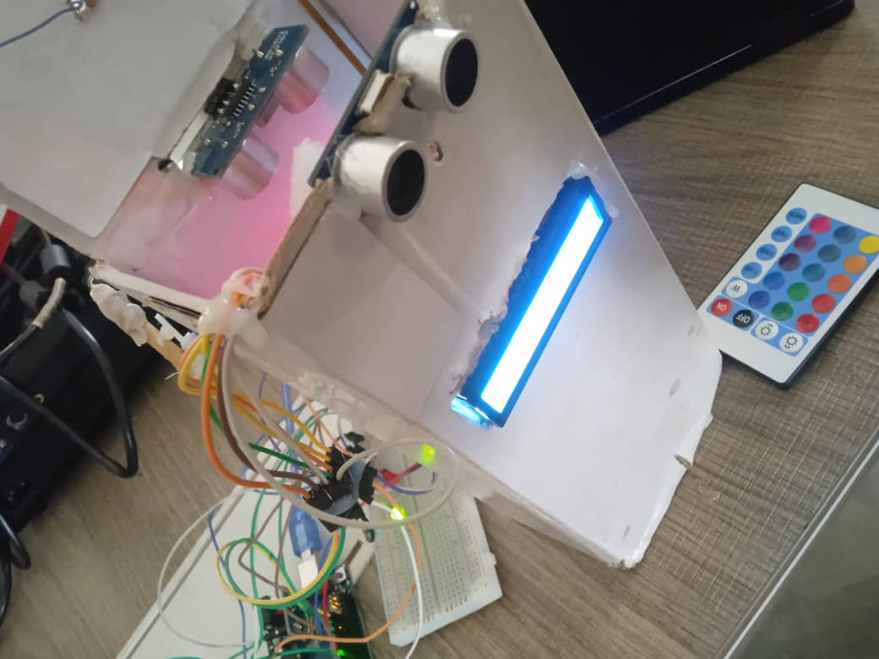

**Figure 3.1:** A picture showing the Smart Bin Project.

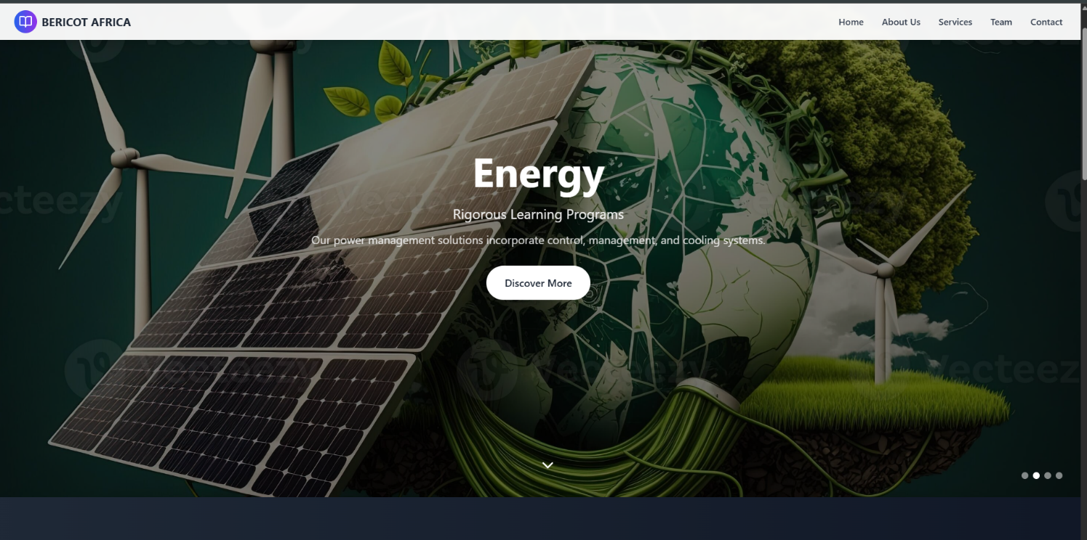

**Figure 3.2:** A picture showing a company website page

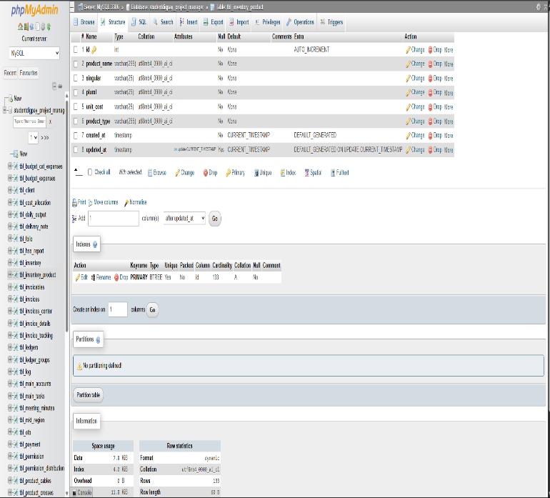

**Figure 3.3:** A picture showing a database in phpMyAdmin interface, a web-based tool used to manage MySQL.

**Figure 3.4:** A picture of the API of the stock management project.

**Figure 3.5:** A picture of the home admin page of an existing real-world system created by the company.

**4 CHAPTER FOUR: CONCLUSIONS AND RECOMMENDATIONS**

**4.1 Conclusions**

The internship experience I had at Araknerd Company Limited from June through August 2025 provided me with a genuine understanding of technology industry work. University education focuses on theory but my internship provided me with the practical experience I needed.

**What I Actually Learned**

My biggest achievement happened when I realized how classroom material translates into practical applications in real life. The programming principles from Software Construction and OOP became clear to me when I developed the stock management application with React and Node.js. The three-day battle to fix my backend-frontend connection issue showed me that debugging remains an essential aspect of development work.

My experience with Arduino devices and sensors represented a complete unfamiliar territory to me. We learned about embedded systems in university but wiring LEDs servos and ultrasonic sensors for a smart bin exceeded my expectations. A textbook explanation does not compare to watching the LCD display activate after successful code execution.

**Working in a Real Company**

Before this internship, I had no idea what it's like to work in a team on actual projects. At university, group work is usually just splitting up assignments, but at Araknerd, everyone actually depends on each other. When we were doing the biometric sign-ins at Elite High School, I had to work with the technical team to solve problems on the spot when students couldn't scan their fingerprints properly.

My supervisors were really patient with me, especially when I was struggling with PHP or couldn't figure out why my React components weren't rendering properly. They didn't just give me the answers - they made me think through the problems, which was frustrating at first but really helped me learn.

**How University Prepared Me (And Where It Didn't)**

The majority of my educational content from Makerere proved beneficial in my studies. The programming basics from Software Construction enabled me to learn React rapidly. The knowledge from Database Structures became practical when studying MongoDB. The Computer Architecture course provided valuable knowledge that assisted me during my work with IR remote sensor hexadecimal values.

University education failed to provide me with essential practical training that I needed for my work. Our curriculum lacked Git training while excluding React and Node.js frameworks and did not include any interaction with real clients. The communication course was beneficial because I could converse with both team members and school students without experiencing shyness.

**What This Means for My Career**

The internship experience made me genuinely enthusiastic about technology. My initial plan was to do basic coding yet I found myself developing web applications while building hardware projects and assisting with electronic voting systems. I learned that numerous career directions exist for me to explore.

My career goal includes working as a full-stack developer while continuing to engage with embedded systems. My most enjoyable project became the smart bin because it merged programming with physical devices and demonstrated real-time functionality. My goal is to develop technology which delivers practical assistance to people.

**4.2 Recommendations**

Based on what I experienced, here's what I think could be improved:

**For Makerere University**

**Update the Curriculum**

* We need to learn modern frameworks like React and Node.js, not just basic HTML and CSS. Every company is using these now.
* More hands-on projects that last the whole semester, not just small assignments.
* Teach us Git and how to work on projects together, because that's what we'll actually do at work.
* The embedded systems course should have more Arduino projects. What we did in class was too basic.

**Make Field Attachments Better**

* Give us some training on professional communication and workplace behavior before we go out. I figured it out, but it would have been helpful.
* Check on us more during the attachment. My academic supervisor only visited once.
* Help us find better companies for attachments. Some of my classmates ended up in places where they just did data entry.

**For Araknerd Company Limited**

**Make the Internship More Structured**

* Maybe create a checklist of things interns should learn by the end. I learned a lot, but it was kind of random.
* Give us more time with different teams. I only worked with software and embedded systems but would have liked to see mobile development too.
* Some documentation on how things work at the company would be helpful. I spent a lot of time figuring out basic stuff.

**Better Project Planning**

* Start with easier projects and build up to harder ones. The stock management app might have been too complex for my first week.
* Make sure intern projects are actually useful to the company, not just busy work.

**For Future Students**

**Before You Go**

* Learn React and Node.js on your own before the attachment. YouTube and freeCodeCamp are good resources.
* Build some personal projects to show what you can do. Even simple ones help.
* Practice explaining technical stuff to non-technical people. You'll need this when working with clients.

**During Your Attachment**

* Ask lots of questions. Everyone expects you to not know everything.
* Take notes on what you learn each day. It helps when writing your report.
* Don't be afraid of challenging tasks. The hard stuff is where you learn the most.
* Be friendly with everyone, not just your supervisor. You never know who might help you later.

**Skills to Focus On**

* Version control (Git) - every company uses this
* Problem-solving - you'll spend a lot of time debugging
* Working in teams - it's different from university group work
* Basic project management - knowing how to organize your tasks

**For Universities and Companies**

**Work Together More**

* Companies should tell universities what skills they actually need from graduates.
* Have more guest lectures from people working in tech companies.
* Create projects where students work on real company problems.

**REFERENCES**

Araknerd Company Limited. (2025). Company information and project documentation.

Elite High School. (2025). Biometric attendance system and e-voting implementation.

Makerere University. (2023). Bachelor of Science in Computer Science program. School of Computing and Information Sciences.

National Curriculum Development Centre. (2024). Secondary school coding curriculum guidelines. Ministry of Education and Sports, Uganda.

Standard High School. (2025). Student data management system documentation.

Various online resources including:

* React.js official documentation (reactjs.org)
* Node.js documentation (nodejs.org)
* Arduino programming guides (arduino.cc)
* MongoDB documentation (mongodb.com)
* PHP development resources (php.net)

**APPENDICES**

**Appendix A: My Weekly Progress**

**Summary of What I Did Each Week**

**Week 1 (June 6):** Started with biometric sign-ins at Elite High School. Got introduced to React but struggled with grid components and backend connections.

**Week 2 (June 13):** Finally fixed the backend-frontend issue after 3 days of debugging. Built my first school website with React.

**Week 3 (June 20):** Created a private company website and started learning PHP. Still had issues with backend routes crashing.

**Week 4 (June 27):** Participated in e-voting at Elite High School and handled data entry for Standard High School’s student ID card system, using Faststone Photo Resizer to batch resize and input data efficiently. Explored PHP further and with team support, connected an existing system’s database to a local WAMP server for testing, aiming to replicate a stable development environment and successfully managed it via the phpMyAdmin interface to ensure functional backend operations. And gaining hands-on experience with local server environments. Had problems with React build errors and unresolved stock tracking routing issues.

**Week 5 (July 4):** Built another React web app and started working with Arduino. Still couldn't fix the stock tracking routing.

**Week 6 (July 11):** Finally got to work with hardware! Used servo motors, LEDs, and ultrasonic sensors with Arduino.

**Week 7 (July 18):** Designed a smart dustbin using LCD, servo, and sensors. This was challenging but fun.

**Week 8 (July 25):** Added IR remote control to the smart bin. Everything was working well.

**Week 9 (August 1):** Modified the smart bin and started learning about line-following robots. Had some issues with the lid closing mechanism.

**Skills I Gained Each Week**

* **Weeks 1-3:** React basics, debugging, PHP introduction, working with teams.
* **Weeks 4-6:** More React, Arduino programming, database understanding.
* **Weeks 7-9:** Advanced sensor work, independent project management, hardware-software integration.

**Appendix B: Projects I Worked On**

**Stock Management App**

* **What it does:** Tracks inventory, adds/removes items, shows stock levels
* **Technology:** React, Node.js, TypeScript, MongoDB
* **Biggest challenge:** Backend wouldn't connect to frontend for 3 days
* **What I learned:** Debugging skills, database connections, API design

**Smart Bin Prototype**

* **What it does:** Opens automatically when you approach, shows if it's full, controlled by remote
* **Hardware:** Arduino, ultrasonic sensor, servo motor, LCD display, IR sensor
* **Programming:** C++ with libraries for sensors and display
* **What I learned:** Hardware programming, sensor integration, problem-solving with physical devices

**Company Websites**

* **What I built:** School website converted to private company website
* **Technology:** React, JavaScript, Tailwind CSS
* **Challenges:** CSS themes not loading properly, had to rebuild parts
* **What I learned:** Web design, responsive layouts, fixing build errors

**School Fieldwork**

* **Biometric System:** Helped students sign in using fingerprint scanners
* **E-voting:** Supported student elections with technical assistance
* **Data Entry:** Updated student information for ID card systems
* **What I learned:** Client interaction, real-world system deployment, troubleshooting under pressure

**Appendix C: Photos and Screenshots**

Note: Photo documentation of fieldwork activities was limited due to client privacy policies at educational institutions. Available screenshots and technical documentation are included in the main report.

**Appendix D: Code Sample**

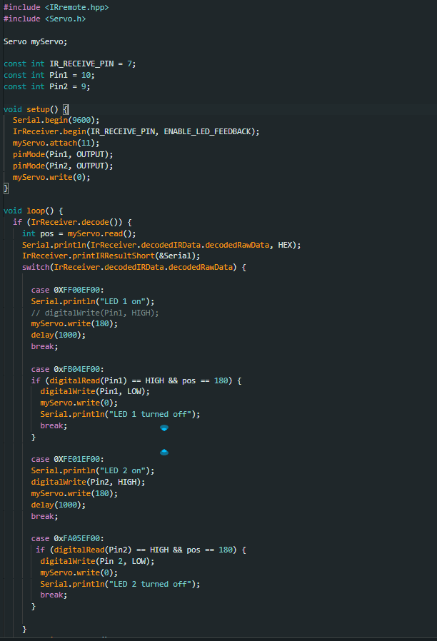

**Arduino Code for configuring a remote.**

**Appendix E: What I'd Tell Other Students**

**Before Your Attachment**

1. Learn Git - every company uses version control.
2. Build some projects on your own - even simple ones show initiative.
3. Practice explaining code to others - you will need this skill.
4. Get comfortable with debugging - you will do a lot of it.

**During Your Attachment**

1. Ask questions - no one expects you to know everything.
2. Take on challenging tasks - that is where you learn the most.
3. Be friendly with everyone - not just your supervisor.
4. Document what you learn - helps with the report later.

**Skills That Actually Matter**

1. Problem-solving - more important than knowing specific languages.
2. Learning new things quickly - tech changes fast.
3. Working with others - most projects need teamwork.
4. Communication - you will need to explain your work to non-technical people.

**Common Mistakes to Avoid**

1. Being too shy to ask for help.
2. Only doing exactly what you are told - show some initiative.
3. Ignoring the business side - understand why you are building what you are building.
4. Not networking - the connections you make matter.

*This report documents my field attachment experience at Araknerd Company Limited from June to August 2025. It represents my personal learning journey and observations during this important part of my Computer Science education at Makerere University.*

**Name:** Ssimbwa Bright Samuel  
**Registration Number:** 23/U/1437  
**Date:** August 15, 2025

**Student's Weekly Progress Report**

**Name:** Ssimbwa Bright Samuel **Reg No:** 23/U/1437

**Course:** Bachelor of Science in Computer Science

|  |  |  |  |  |  |  |
| --- | --- | --- | --- | --- | --- | --- |
| **Report Date** | **Date**  **Submitted** | **Task Completed** | **Task in Progress** | **Next Week's Task** | **Problems / Challenges** | **Field Supervisor**  **Comments** |
| 06-06-2025 | 06-06-2025 | Signing in reporting students at Elite High School using biometric devices that is finger print scanner. Developing a stock management app using React & Node.js with Typescript. Engaging in the new installed "buzz time" booth systems that are enhanced compared to the  common "MTN" yellow booths by Araknerd Company limited. Introducing coding to S.1 students as a subsidiary subject in the new curriculum at Elite High School and preparing them for HTML Solved the gird component issue. | Leaning more into react and developing a website for Elite High School as well as continuing to develop the Stock Management app and resolving the issue with backend server link with that of the frontend. | Engaging more into React and enhancing the stock management app. Developing a website. Engaging more into some of the projects handled at the company such as the enhanced booth systems being introduced into some schools such as Elite High School, Standard  High School, Zana, Gombe SS, Kitende SS and others. | Errors when compiling front end when using the grid component while using react, node.js. Backend refusing to connect with the frontend when both servers are running locally. During reporting students signing in, few reported, some arrived at odd times(arriving so late), others didn't have their data filled into the system. | Bright excelled in biometric sign-ins at Elite High School though the grid component issue he is facing needs focus. He also witnessed out buzz time advanced booth system setup. |

|  |  |  |  |  |  |  |
| --- | --- | --- | --- | --- | --- | --- |
| 13-06-2025 | 13-06-2025 | Solved the issue hindering backend and frontend from connecting locally. Created a school website using React. Got more engaged into React. | Changing the school website into a private company website. Learning Php in order to interact with an existing system. | School website is to be turned into a Private company website using React. Stock tracking app: URL consistencies. Learning Php to work with React/Php. | It took 3 days to figure out the issue hindering the backend from connecting with the frontend. URL problem; the application runs, stock is added as the terminal says but nothing gets stored in the database and the error is not displayed in terminal when logging is added to the code. | Bright resolved the backend-frontend issue and that shows his ability to learn coding with Php is promising. He should streamline debugging to avoid delays. |
| 20-06-2025 | 20-06-2025 | Created a private company website using react with JavaScript and tailwind css. Actively engaged in learning php with html. | Stock management app backend route correcting. | Engaging into an existing company system built with React and Php.  Finalizing stock management app backend route correction. Creating a react web application. | Stock management app backend routes crashing every now and then. | Bright delivered a private company website  using react and advanced his Php skills and that is great. The backend route crashes in the stock app persist and he needs to apply target fixes. |
| 27-06-2025 | 02-07-2025 | Participated in E-voting at Elite High school. School system data filling for students' ID cards. | Engaging with an existing private company website. Rebuilding the react website. | Rebuilding React website due to profound errors while building with vite. Starting on C++. Php server set up with preexisting database. | Inability to discover the errors hindering the smooth running of the stock tracking project. React website errors with loading the css themes as expected. | Bright supported e-voting and data Entry for Standard High School. He knew how to work around any technical issues that students faced without any help. He is a promising student. |

|  |  |  |  |  |  |  |
| --- | --- | --- | --- | --- | --- | --- |
| 04-07-2025 | 14-07-2025 | Created a react webapp. | Correcting the routing in the stock tracking project app. | Engaging in the technical department of the company, working with the Arduino to do certain tasks as assigned. | unable to find the root cause of the routing failure in the stock tracking app. | Bright created React Web and worked on the stock routing issues making sure to seek guidance where he got really stuck. Continued focus on resolving technical errors will strengthen his contributions. |
| 11-07-2025 | 14-07-2025 | working with a servo, LED, Ultrasonic sensor and Arduino. | Continuing with the use of the Arduino and do more tasks. | Continuing with the use of the Arduino and do more tasks. | None | Bright has now engaged in with the technical department of our company and he seems very eager to learn. I recommend that he continues to discover where his energy lies so that he can accomplish a lot especially in fields that are of greater interest. |
| 18-07-2025 | 24-07-2025 | Configuring the use of a potentiometer with a servo, displaying text on a lcd, controlling light intensity with a potentiometer. Setting up the design for the Smart bin. | Designing a Smart dustbin using an LCD, Servo, Ultrasonic Sensors and or IR sensor, and Arduino. Learning C++ that is used with the Arduino. | Designing a Smart dustbin using an LCD,  Servo, Ultrasonic Sensors and or IR sensor, and Arduino. | Timing the operations of both Bin sensors to check whether bin is full or not so as to open for one to use the bin. | Bright has been tasked with a project of creating a smart bin and he is to do this alone to test his potential and eagerness to delve into technical areas. He should overcome any challenges as expected of him. |

|  |  |  |  |  |  |  |
| --- | --- | --- | --- | --- | --- | --- |
| 25-07-2025 | 01-08-2025 | None | Introduction to IR remote sensor. | Working with an IR remote sensor together with several equipment; LEDs,  Servo, and ultrasonic sensors. | None | Bright was able to complete the task assigned to him and I'm impressed. And I see he is even desiring to do more. If he continues this way, he'll surely make a great pillar for the upcoming IT generation. |
| 01-08-2025 | 01-08-2025 | Modified the smart bin to now use an IR remote sensor as secondary to opening it. Introduction to a Line following robot. | Rectifying the closing lid issue. | None assigned. | There is a problem with assigning a closing override button for the lid. The remote only responds to the opening and does not close until the assigned delay period is done yet the goal is to have an opening and closing button to both work seamlessly. | Continued to improve troubleshooting efficiency and demonstrated better understanding of hardware. |